OCA:
1Z0-808-JPN: Java SE 8 Programmer I
https://www.pearsonvue.com/us/en/oracle.html

Module | Hours
Building box | 2 hrs
Operators | 45 min
Flow Control | 1 hours
Strings | 1 hours
Arrays | 20 min
Dates | 25 min
Methods | 1 hours
Class Design | 1.5 hours
Abstract classes and interfaces | 0.5 hours
Lambda and Functional | 1.5 hours
Collection | 1.5 hours
Exceptions | 35 min
 | ~10 hours

Dates
java.time Package: This is the base package of new Java Date Time API. All the commonly used classes such as LocalDate, LocalTime, LocalDateTime, Instant, Period, Duration are part of this package. All of these classes are immutable and thread safe.

java.time.format Package: This package contains classes used for formatting and parsing date time objects such as java.time.format.DateTimeFormatter.

Flow Control

SWITCH Statements
Switch (variable) {
case constantExpression1:
// code
break;
default:
//code
}

Note:
Boolean, double, float are not allowed variable types.
Default block is optional, and it can place anywhere in the cases. Careful with default statement, because the code will execute all other cases below the default statement if there is no break statement.

It is easier than if, else statements.

Class Designing

Inheritance
Java doesn’t have multiple inheritance,
Java inheritance is transitive (transfer from parament to child)
Extends keyword is used.

Encapsulation
If you want to some fields and methods protected, you can restrict those using private access modifiers, and they can be accessed through the public getters and setters methods.

Variables
Java has method variables and instance(class) variable. Use “this” key word for identifying instance variable without confused with the method variable.
public setAge (int age) {
this.age = age; // this.age refers to instance variable age.
}
Same as if you wanted to access instance variable/method of Super class, you could define the instance variable or method using “super” key word.

Constructors
- Could be public, protected, or private access type.
- Doesn’t have return type.
- Same as the class name.
- Constructor will create object and execute once you call the class instance.
- Constructor can be overload (should change the method signature)
- There will be default constructors created if there is no other constructors are created by the developer.
- If you create no argument constructor in class initialization, it will give compilation error if your constructor is having arguments.
Class Dog () {
Int age;
String name;
Dog (int age, String name) {
this.name = name;
this.age = age;
}
}

public static void main (String[] args) {
Dog dg1 = new Dog (); // ERROR – there is no default constructor,
Dog dg2 = new Dog (10, “Blacky”); // Compile OK
}

Abstract classes and interfaces
Interface classes are implicitly public and abstract. You do not need to explicitly mention.

All methods in interface class are public and abstract, you do not need to explicitly mention.

All fields in interface classless are CONSTANTS in interfaces and public static and final.
i.e.

public abstract interface Car {
public abstract int distanceWithFuel (int fulelVolume);
public static final in MAX_WEIGHT = 2000;
}

Interface class may have default methods, which are not abstract methods. But it should be public.

To retrieve default methods, you must use “super” keyword

i.e.

@Override
public void sleep() {
super.sleep();
System.out.println("snoring!!");
}

Abstract Class | Interface
Can have both abstract methods and concrete methods implementations | Before Java 8: Only abstract methods.  Java 8+: Can have default and static methods.  Java 9+: Can have private methods.
Use “class” key word | Use interface key word
Class should extend | Class should implement
One abstract class can be extended | Multiple interfaces can be implemented
Can have instance variables, static variables, and constants | Can only have constants (implicitly public static final).
Can use all access modifiers (public, protected, private) for abstract methods | Methods are implicitly public abstract (except default, static, and private in Java 8+)
Can have constructors | Cannot have constructors.

Lambda and Functional Interface
A functional interface in Java is an interface that contains exactly one abstract method.
- Single Abstract Method
- @FunctionalInterface Annotation
- Without creating Concreate class, you can directly implement abstract method in your main class.
- Useful with providing different implementation in a single class.
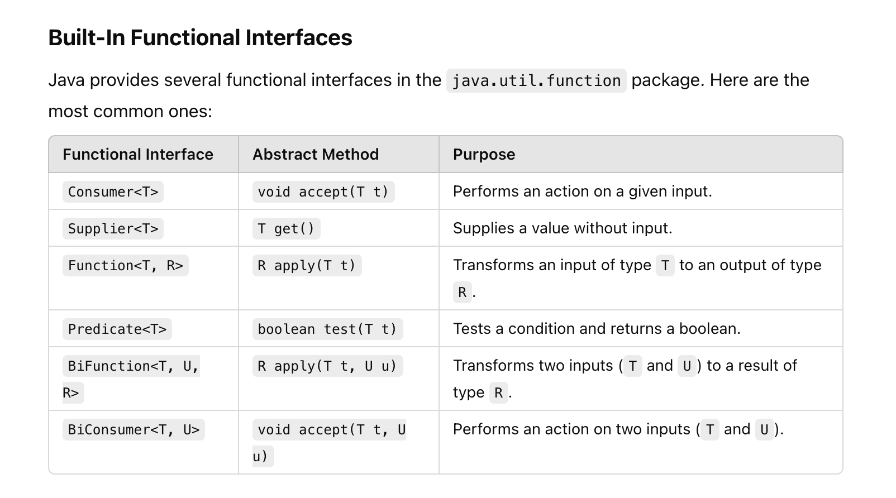

Lambda

Implementation of Abstract method in a functional interface.

@FunctionalInterface
interface Calculator {
int add(int a, int b); // Single abstract method
}

public class MainClass {
public static void main(String[] args) {

// Using a lambda expression
Calculator calculator = (a, b) -> { return a + b; } ;
System.out.println("Sum: " + calculator.add(5, 10)); // Output: Sum: 15
}
}

JAVA Predicates:
- Those are pre-defined functional interfaces introduced by JAVA
- Java.util.funtion package should be used
- Having one abstract method call test (T), which takes any types of variables we defined, and returns boolean

Use Cases:

Runnable task = () -> System.out.println("Task is running");
new Thread(task).start();

Data Types:

- Primitives are not objects
- Each primitive has wrapper classes
Note: wrapper classes are useful to convert values of data types.

Primitive Type | Wrapper Class | Example
boolean | Boolean | Boolean.valueOf(true)
byte | Byte | Byte.valueOf((byte) 12)
short | Short | Short.valueOf((short) 12)
Int | Integer | Integer.valueOf(12)
long | Long | Long.valueOf(12L)
float | Float | Float.valueOf(12.0F)
double | Double | Double.valueOf(12.0)
char | Character | Character.valueOf(‘c’)

What is autoboxing in wrapper class: Wrapper classes are automatically used when you assign a primitive value to an object of the wrapper class (autoboxing), and when a wrapper class is converted back to a primitive type (unboxing).

